PROJECT REPORT

THE FUTURE OF WORK:DATA ANALYSIS OF GLASSDOOR JOBS

TEAM MEMBERS

**Team id**: LTVIP2023TMID08294

**Team size:5**

**Team Leader :** Palyam Suresh

**Team member :** MALLEPOGULA SRAVANI

**Team member :** MANDLI JAISAI

**Team member :** M ISMAILZABIULLA

**Team member :** P Bhargavareddy

### The Future Of Work: Data Analysis Of Glassdoor Jobs

Job analysis is a systematic procedure to analyse the requirements for the job role and job profile. Glassdoor is a website and online platform that provides information about jobs, salaries, and companies. Job analysis is a systematic approach to defining the job role, description, requirements, responsibilities, evaluation, etc. It helps in finding out required level of education, skills, knowledge, training, etc for the job position. It also depicts the job worth i.e. measurable effectiveness of the job and contribution of job to the organization. Thus, it effectively contributes to setting up the compensation package for the job position.

Lack of analysis of Glassdoor jobs can result in limited understanding of job market trends, difficulty in finding relevant job opportunities, inability to attract and retain top talent, and lack of insight into company branding and reputation.

The purpose of this project is to conduct an analysis of Glassdoor job postings to gain insights into current and emerging job market trends, identify in-demand skills and experience, and understand how employers can improve their employer branding and reputation to attract and retain top talent.

**Project Flow**

**Project Flow**

To accomplish this, we have to complete all the activities listed below,

* Define Problem / Problem Understanding
  + Specify the business problem
  + Business requirements
  + Literature Survey
  + Social or Business Impact.
* Data Collection & Extraction from Database
  + Collect the dataset,
  + Storing Data in DB2
  + Perform SQL Operations
  + Connect DB2 with Cognos
* Data Preparation
* Prepare the Data for Visualization
* Data Visualizations
  + No of Unique Visualizations
* Dashboard
  + Responsive and Design of Dashboard
* Story
  + No of Scenes of Story
* Report
  + No of Visualization with detail information
* Performance Testing
  + Amount of Data Rendered to DB2
  + Utilization of Data Filters
  + No of Calculation Fields
  + No of Visualizations/ Graphs
* Web Integration
  + Dashboard, Report and Story embed with UI With Flask
* Project Demonstration & Documentation
  + Record explanation Video for project end to end solution
  + Project Documentation-Step by step project development procedure
* **Define Problem / Problem Understanding**
* Problem understanding in the context of the future of work and Glassdoor jobs refers to the process of comprehending and addressing the challenges, shifts, and trends that are emerging in the job market and workplace dynamics, as well as how Glassdoor, a job and company review website, plays a role in this evolving landscape. This involves identifying and analyzing the issues, uncertainties, and opportunities that individuals, employers, and society at large face in relation to employment and career-related matters, particularly through the lens of information and reviews available on the Glassdoor platform
* Identifying the Problem: The first step is to identify the problem or the issue that needs to be addressed. This requires recognizing the gap between the current state and the desired state or understanding what obstacles are hindering progress.
* Defining the Problem Scope: : Defining the problem scope related to the future of work in the context of Glassdoor jobs involves understanding and addressing various challenges, trends, and opportunities that are emerging as the traditional work landscape evolves.
* Gathering Information : Glassdoor is a website where employees and former employees anonymously review companies and their management. It also provides salary information and job listings. Glassdoor's job listings cover a wide range of industries and job types, from entry-level to executive positions.
* Analyzing the Problem: Glassdoor is a website that offers insights into company reviews, salaries, interview experiences, and job listings. When analyzing problems related to Glassdoor jobs, there are several aspects to consider:
* Fake or Biased Reviews**:** One common issue is the presence of fake reviews or biased feedback. Some companies might try to manipulate their ratings by posting positive reviews themselves or posting negative reviews about competitors. This can mislead job seekers and potential employees.
* Inaccurate Salary Information**:** Glassdoor provides salary information for various job positions, but this data might not always be accurate or up-to-date. Discrepancies can arise from factors such as location, job responsibilities, and experience levels, leading to misleading salary expectations.
* Lack of Context**:** Reviews and ratings might lack context, making it difficult to fully understand the work environment, company culture, or reasons behind certain ratings. What might be a negative aspect for one person could be acceptable to another.
* Sample Bias**:** The reviews and ratings on Glassdoor might not represent a company's entire workforce or provide a balanced perspective. Dissatisfied employees might be more motivated to leave reviews, potentially skewing the overall perception.
* Limited Industry Coverage**:** Glassdoor might have more information available for certain industries or sectors, while others might be underrepresented. This can limit the usefulness of the platform for job seekers in specific fields.
* Privacy Concerns**:** Some reviews might contain personal or sensitive information that could potentially violate individuals' privacy or legal boundaries.
* Unverified Information**:** Glassdoor relies on users to provide information, and there might be instances where the information provided is unverified or incorrect. This could lead to misinformation for job seekers.
* Filtering and Sorting Challenges**:** The website's filters and sorting options might not always yield the most relevant or accurate results, making it harder for users to find the jobs they are looking for.
* User Experience**:** The user experience on Glassdoor, including website navigation and search functionality, can impact how effectively users can find relevant job information.
* Response from Companies**:** Sometimes, companies might respond to reviews on Glassdoor, either clarifying misunderstandings or addressing concerns. The effectiveness and fairness of these interactions can vary.
* Data Quality and Quantity**:** The quality and quantity of data available for analysis might vary across different companies and job positions. This can impact the reliability of insights drawn from the platform.
* To address these problems, Glassdoor could implement measures such as stricter review verification, enhanced data accuracy checks, improved algorithms for filtering and sorting, and increased transparency about their data collection methods. Additionally, they could encourage companies to actively engage with their employees' reviews to foster a more balanced representation of workplace experiences.

* Stakeholder Identification: Stakeholder identification is a crucial process when analyzing the future of work, specifically in the context of Glassdoor jobs. Identifying stakeholders involves recognizing individuals, groups, and organizations that have an interest, influence, or impact on the topic.
* Understanding Constraints and Requirements: Glassdoor is a website that allows employees and former employees to anonymously review companies and their management. While it provides valuable insights into company cultures, interview processes, salaries, and work environments, it might not explicitly lay out the future of work's constraints and requirements.
* Problem Statement: In the rapidly changing landscape of work, the emergence of online platforms like Glassdoor has significantly altered how employees perceive, review, and engage with their workplaces. The future of work is marked by technological advancements, shifting organizational structures, and changing expectations of the workforce. Understanding the implications of Glassdoor job reviews on the future of work is critical for employers, employees, and policymakers.

**Specify the business problem**

Refer Project Description

* In recent years, the concept of the "future of work" has gained significant attention as technological advancements, evolving job roles, and changing employee expectations continue to reshape the employment landscape. For a platform like Glassdoor Jobs, which facilitates the connection between job seekers and employers, addressing the challenges and opportunities presented by the future of work is crucial.
* Addressing these challenges requires Glassdoor Jobs to not only update its technical capabilities but also refine its user experience to empower job seekers and employers in the evolving world of work. By effectively tackling these issues, Glassdoor Jobs can position itself as a forward-thinking platform that facilitates meaningful connections between job seekers and employers in the rapidly changing employment landscape.
* **Business requirements**
* Business Requirements:
* Project Overview**:** Develop a comprehensive analysis and platform enhancement strategy for Glassdoor Jobs that focuses on the evolving landscape of the future of work. The aim is to create a forward-looking, user-centric experience that aligns with the changing needs and expectations of job seekers and employers.
* Market Research and Trend Analysis**:** Gather and analyze data on emerging trends in the job market, including remote work, gig economy, skill shifts, and changing employer-employee dynamics. Identify key areas of focus and potential opportunities for Glassdoor to address in its job listing and recruiting services.
* Enhanced User Experience**:** Improve the overall user experience on Glassdoor Jobs by implementing user-centric design principles. Focus on personalization, ease of use, and accessibility across devices to cater to job seekers from various backgrounds and needs.
* Remote Work Integration**:** Develop features that cater to the growing remote work trend, including search filters for remote job opportunities, virtual interview guides, and tools for assessing a company's remote work readiness.
* Skills and Learning Integration**:** Integrate tools that help job seekers identify and bridge skill gaps based on the changing demands of the job market. Collaborate with online learning platforms or provide skill assessment resources to enhance users' qualifications.
* Company Culture and Diversity Insights**:** Enhance company profiles to provide insights into workplace culture, diversity, and inclusion efforts. This could involve user-generated content, employee testimonials, and sentiment analysis to provide a holistic view of potential employers.
* AI-Powered Job Matching**:** Implement advanced algorithms to provide more accurate job recommendations to users based on their skills, preferences, and the evolving job landscape. Leverage AI to continuously improve the matching process.
* Data Privacy and Security**:** Ensure compliance with data protection regulations (such as GDPR or CCPA) and prioritize the security of user information. Implement robust data protection measures and transparent privacy settings.
* Analytics and Insights**:** Develop a comprehensive analytics dashboard for both job seekers and employers. Provide insights into application success rates, market trends, and the effectiveness of job postings to help employers refine their recruitment strategies.
* Partnerships and Integration**:** Collaborate with emerging HR technologies, career development platforms, and industry associations to stay at the forefront of the future of work trends. Integrate seamlessly with third-party tools that complement the Glassdoor Jobs experience.
* Mobile-First Approach**:** Prioritize a mobile-responsive design to cater to the increasing number of users accessing job listings through smartphones and tablets. Ensure that all features and functionalities are accessible and intuitive on mobile devices.
* Continuous Improvement and Feedback Loop**:** Establish mechanisms for users to provide feedback on the platform's evolving features and the effectiveness of the future of work-related enhancements. Regularly iterate and improve the platform based on user input.
* By addressing these business requirements, the project aims to position Glassdoor Jobs as a leading platform for job seekers and employers to navigate the changing landscape of work effectively. The focus on user experience, data privacy, market trends, and technological advancements will contribute to the platform's success in the future of work.
* **Literature Survey**
* The future of work has been a subject of considerable research and discussion in recent years. Factors such as advancements in technology, changing demographics, globalization, and evolving employee expectations have been reshaping the nature of work and the job market. Glassdoor, as a job and recruiting platform, can offer insights into how these trends are influencing job opportunities and the overall work landscape.
* A literacy survey for Data Analysis of Glassdoor Jobs involves reviewing multiple job roles in a particular domain offered by a particular organisation belonging to a given industry and sector. Job analysis defines the organization of jobs within a job family. It allows units to identify paths of job progression for employees interested in improving their opportunities for career advancement and increasing compensation.
* **Social or Business Impact.**
* Social Impact : Glassdoor is a website that allows employees and former employees to anonymously review companies and their management, as well as share salary information and workplace insights. Glassdoor has significantly impacted the job market by promoting transparency, accountability, and employee empowerment. It has influenced companies to pay more attention to their workplace practices, culture, and employee satisfaction, ultimately contributing to positive changes in the world of work.
* Business Model/Impact : Glassdoor is a platform that allows current and former employees to anonymously review companies and share information about their work experiences, including salaries, company culture, and management practices. Glassdoor reviews can have a significant impact on a company's ability to attract and retain talent, shape its reputation, and maintain a positive workplace culture. Businesses that actively manage their presence on Glassdoor and take employee feedback seriously can benefit in terms of recruitment, employee satisfaction, and overall success.

**Data Collection & Extraction From Database**

Data collection is the process of gathering and measuring information on variables of interest, in an established systematic fashion that enables one to answer stated research questions, test hypotheses, and evaluate outcomes and generate insights from the data.

Collect the dataset: Cleaned_DS_Jobs.csv

**Data Preparation**

In this milestone, we will see how to prepare the data for building visualizations

**Prepare The Data For Visualization**

Preparing the data for visualization involves cleaning the data to remove irrelevant or missing data, transforming the data into a format that can be easily visualized, exploring the data to identify patterns and trends, filtering the data to focus on specific subsets of data, preparing the data for visualization software, and ensuring the data is accurate and complete. This process helps to make the data easily understandable and ready for creating visualizations to gain insights into the performance and efficiency.

**Data Visualization**

Data visualization is the process of creating graphical representations of data in order to help people understand and explore the information. The goal of data visualization is to make complex data sets more accessible, intuitive, and easier to interpret. By using visual elements such as charts, graphs, and maps, data visualizations can help people quickly identify patterns, trends, and outliers in the data.

**No Of Unique Visualizations**

The number of unique visualizations that can be created with a given dataset. Some common types of visualizations that can be used to analyse the Literacy include bar charts, line charts, heat maps, scatter plots, pie charts, Maps etc. These visualizations can be used to compare performance, track changes over time, show distribution, and relationships between variables, breakdown of revenue and customer demographics, workload, resource allocation and location of different job roles.

**Dashboard**

A dashboard is a graphical user interface (GUI) that displays information and data in an organized, easy-to-read format. Dashboards are often used to provide real-time monitoring and analysis of data, and are typically designed for a specific purpose or use case. Dashboards can be used in a variety of settings, such as business, finance, manufacturing, healthcare, and many other industries. They can be used to track key performance indicators (KPIs), monitor performance metrics, and display data in the form of charts, graphs, and tables.

**Responsive And Design Of Dashboard**

The responsiveness and design of a dashboard for analysing the factors important for the analysis of medical care cost analysis are crucial to ensure that the information is easily understandable and actionable. Key considerations for designing a responsive and effective dashboard include user-centred design, clear and concise information, interactivity, data-driven approach, accessibility, customization, and security. The goal is to create a dashboard that is user-friendly, interactive, and data-driven, providing actionable insights

Once you have created views on different sheets in IBM Cognos, you can pin them and pull them into a dashboard.

**Note :** The all above visualizations have created in the dashboard itself, kindly watch the above links

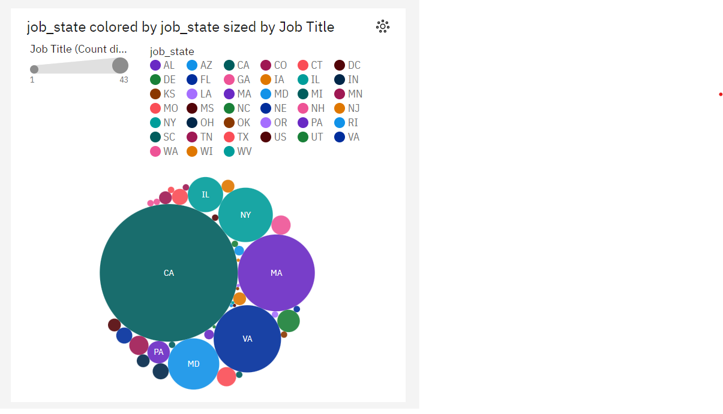

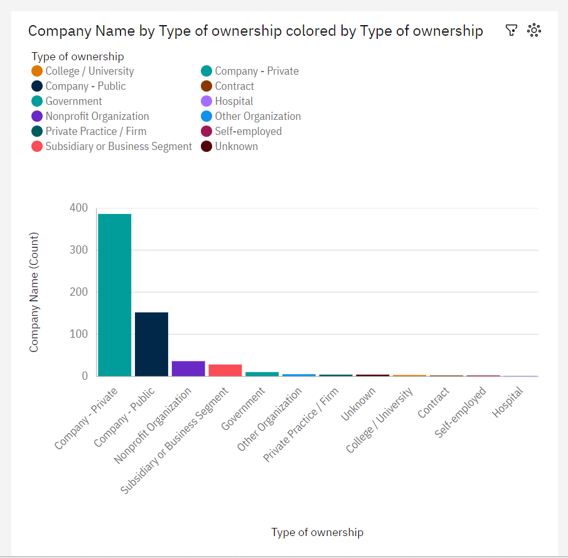

**Story**

A data story is a way of presenting data and analysis in a narrative format, with the goal of making the information more engaging and easier to understand. A data story typically includes a clear introduction that sets the stage and explains the context for the data, a body that presents the data and analysis in a logical and systematic way, and a conclusion that summarizes the key findings and highlights their implications. Data stories can be told using a variety of mediums, such as reports, presentations, interactive visualizations, and videos.

**No Of Scenes Of Story**

The number of scenes in a storyboard for Data-Driven insights on Students Performance will depend on the complexity of the analysis and the specific insights that are trying to be conveyed. A storyboard is a visual representation of the data analysis process and it breaks down the analysis into a series of steps or scenes.

**Scene 1**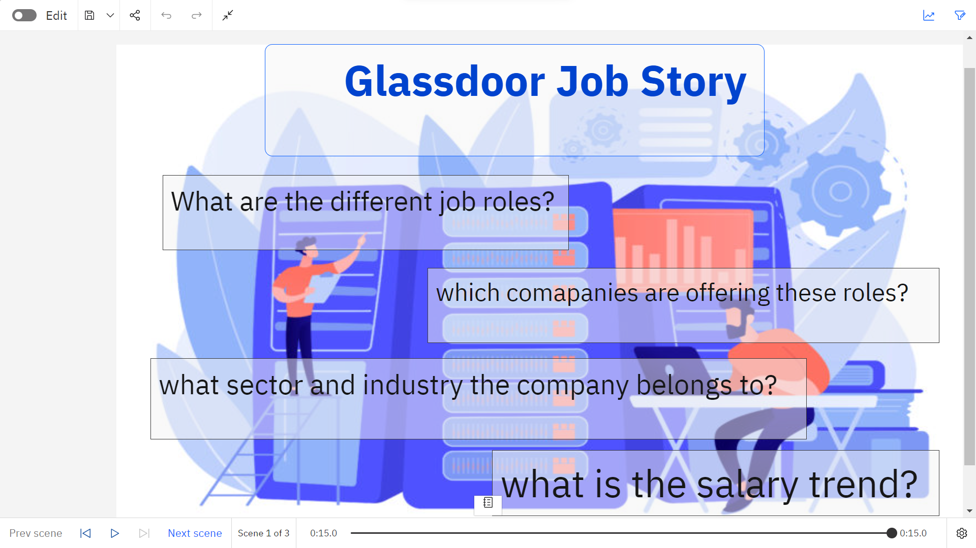

**Scene 2 & 3**

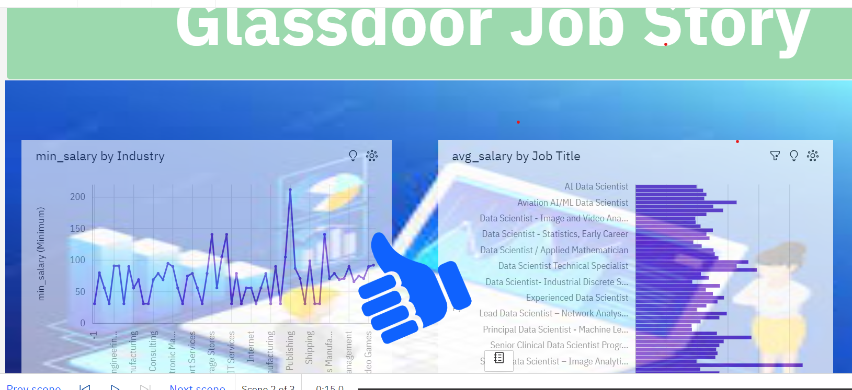

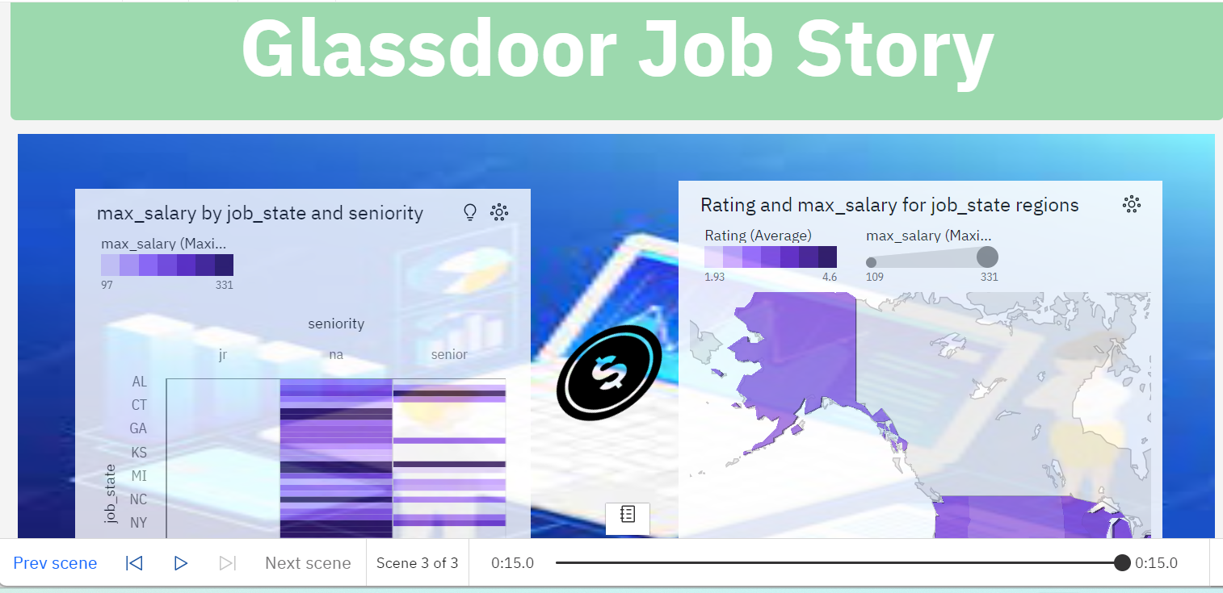

**Report**

A report in data analytics typically involves analysing and interpreting data to draw insights and conclusions that can inform business decisions or address research questions. The report usually includes a summary of the data analysis process, including the methods and tools used, as well as the findings and recommendations based on the analysis. The report should begin with an executive summary, which provides a brief overview of the main findings and recommendations. The introduction should provide background information on the problem or research question being addressed and the data sources used.

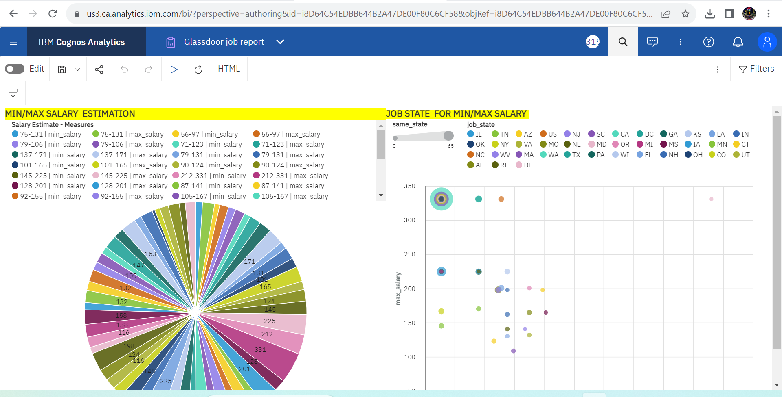

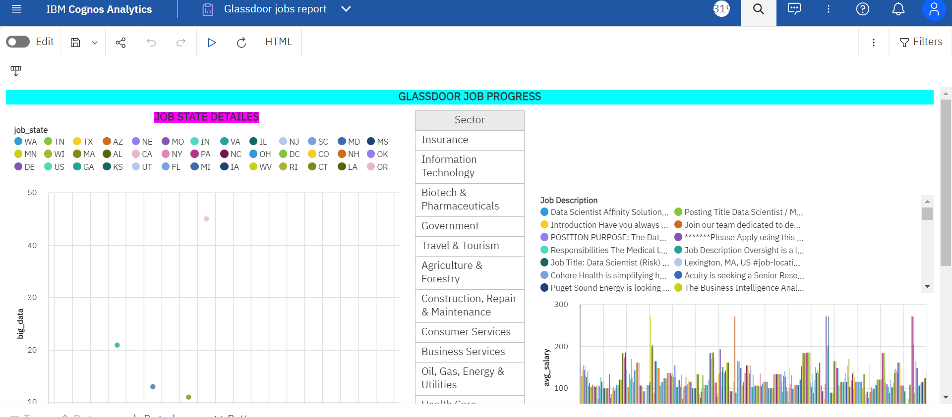

**No Of Visualization With Detail Information**

When creating a report in cognos, it is often helpful to include visualizations to help communicate the findings of the analysis.

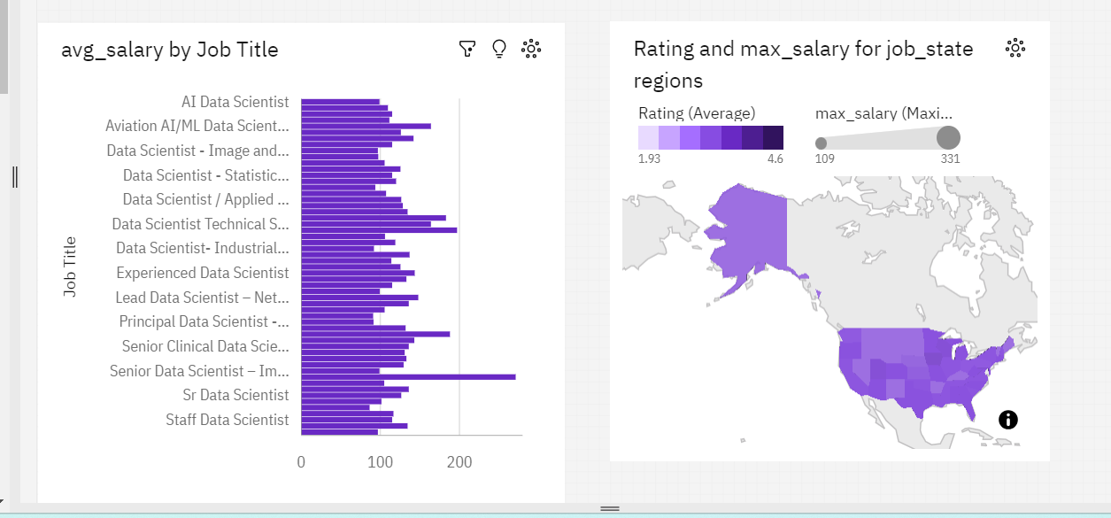

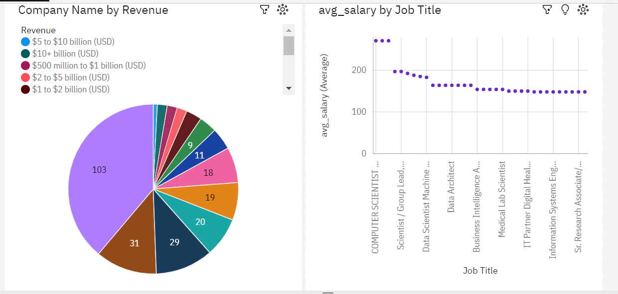

### Performance Testing

**Amount Of Data Rendered To DB2**

The amount of data that is rendered to a database depends on the size of the dataset and the capacity of the database to store and retrieve data.

**Utilization Of Data Filters**

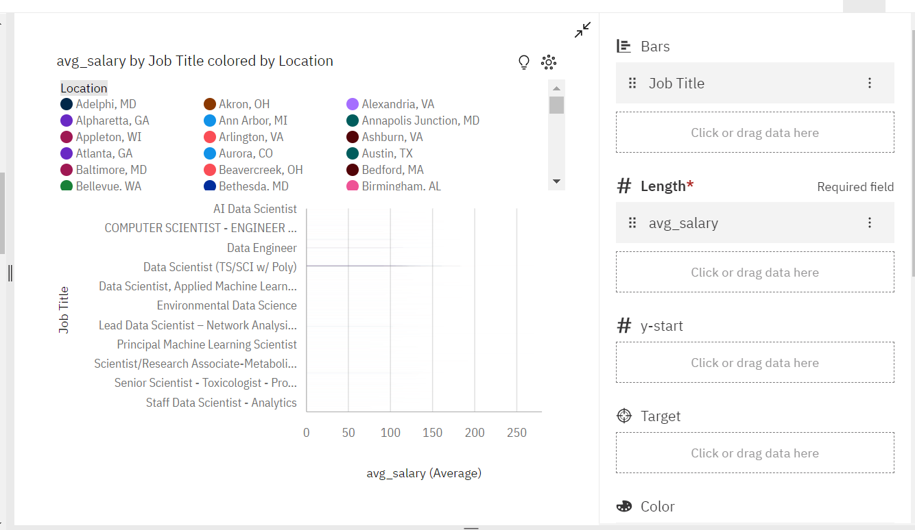

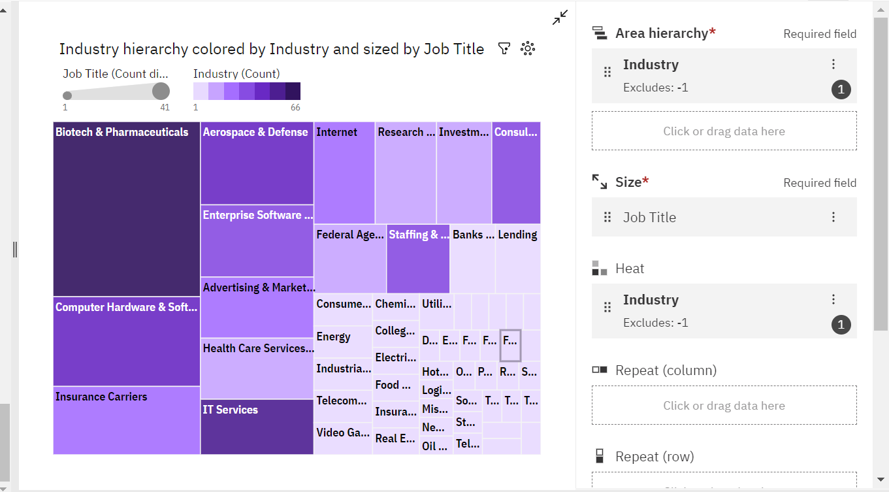

**No Of Calculation Fields**

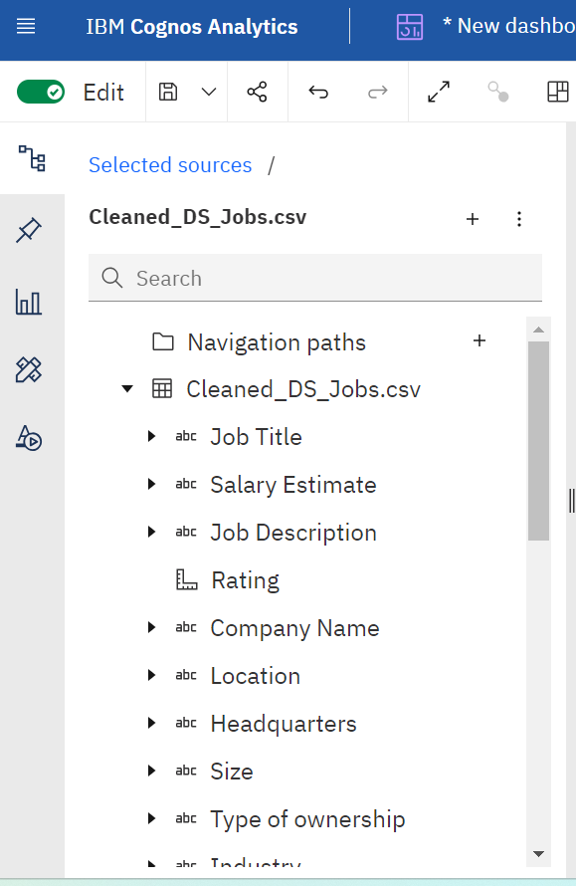

**No Of Visualizations/ Graphs**

1. What is salary trend for a particular job title?

2. No of companies belonging to different Sector

3. How many companies belongs to the particular location?

4. what's the distribution of companies according to the type of owner?

5. Most popular sector on glassdoor for data science domain

6. Top 10 rated jobs

7. Which Industry is offering more job roles

8. Which state is providing more opportunities

9. Show job titles from different category

10. Compare salary trend of different industry

11. Top 10 highest paying jobs from different states

12. what is the avg_salary of Job Title belonging from particular Location

13. What is the revenue generated by companies that falls under particular category of ownership

14. Salary trend for different job titles belonging to particular job category

15. What is the rating & salary offered in particular job state

16. Salary trend in different states for particular seniority level

**Web Integration**

Publishing helps us to track and monitor key performance metrics, to communicate results and progress. help a publisher stay informed, make better decisions, and communicate their performance to others.

**Publishing dashboard,report & story.**

Step 1: Go to Dashboard,report & /story, click on share button on the top.

Dashboard

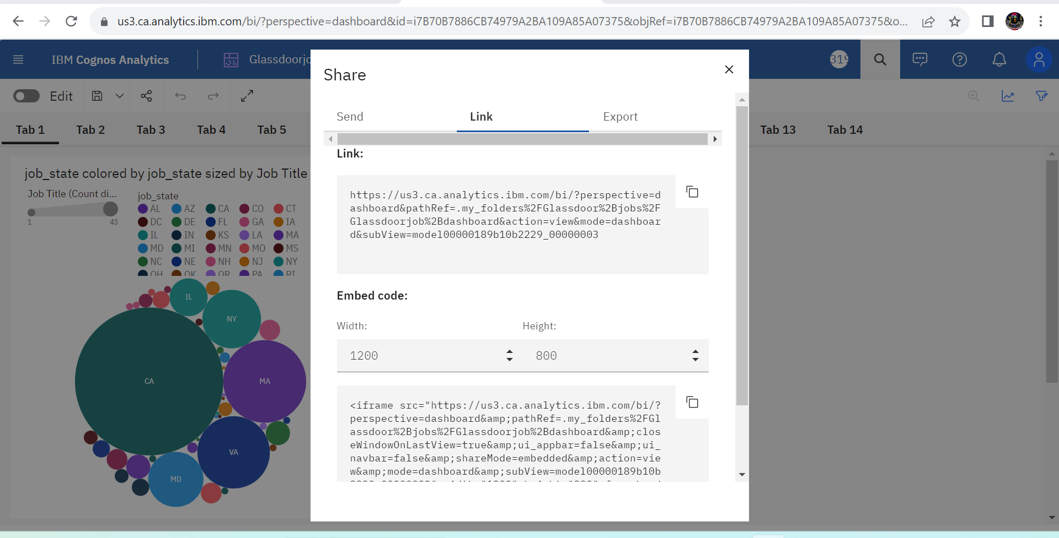

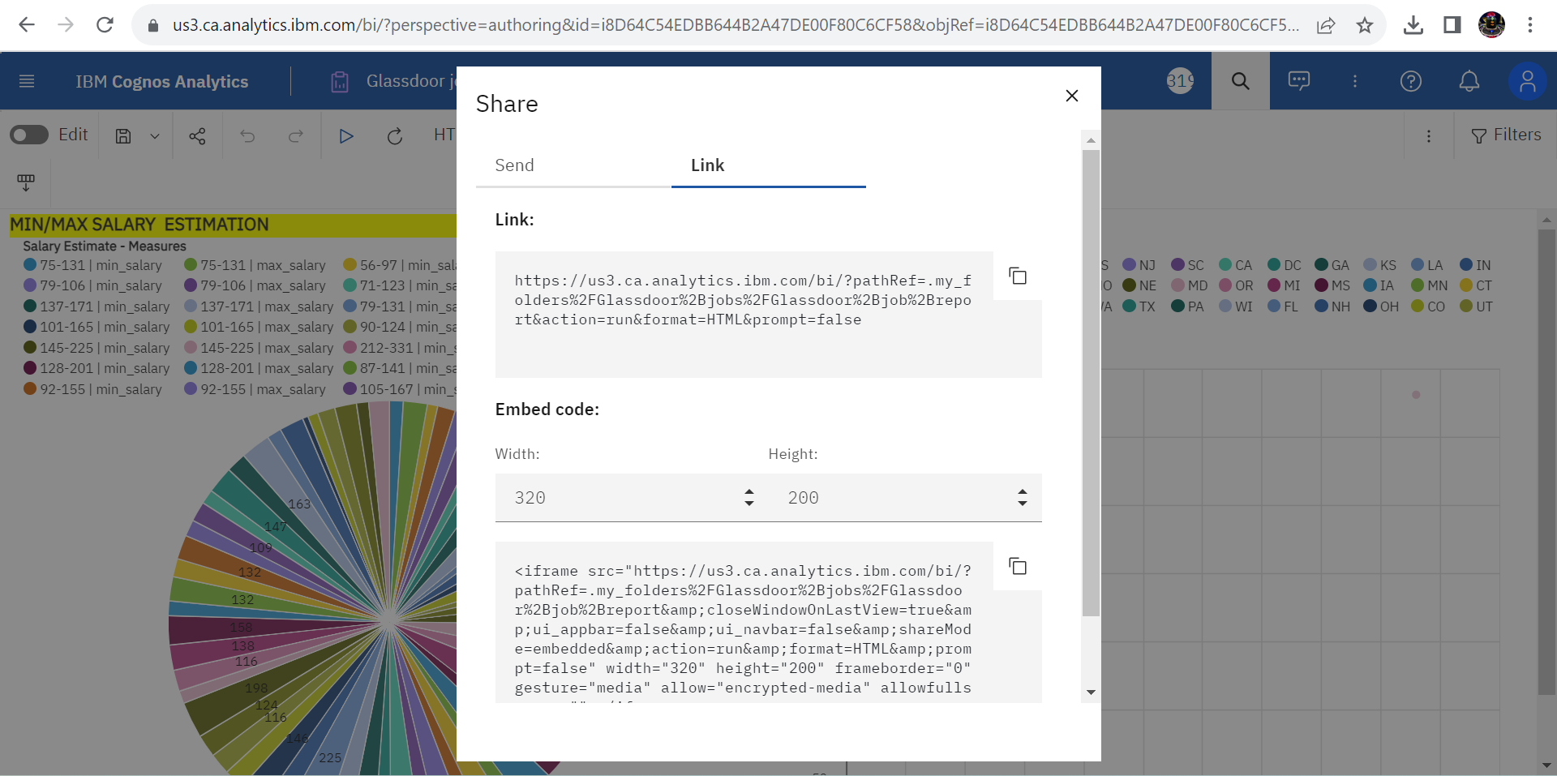

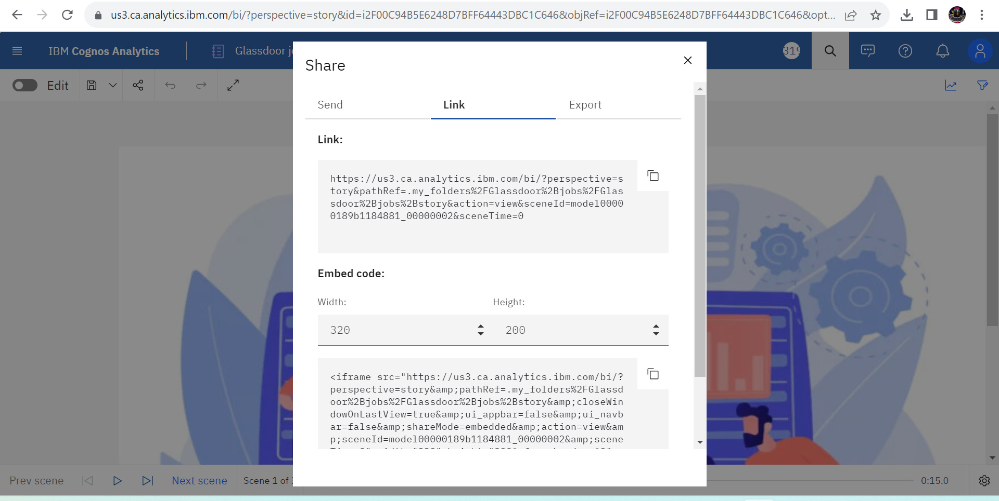

**Dashboard,Report And Story Embed With UI With Flask**

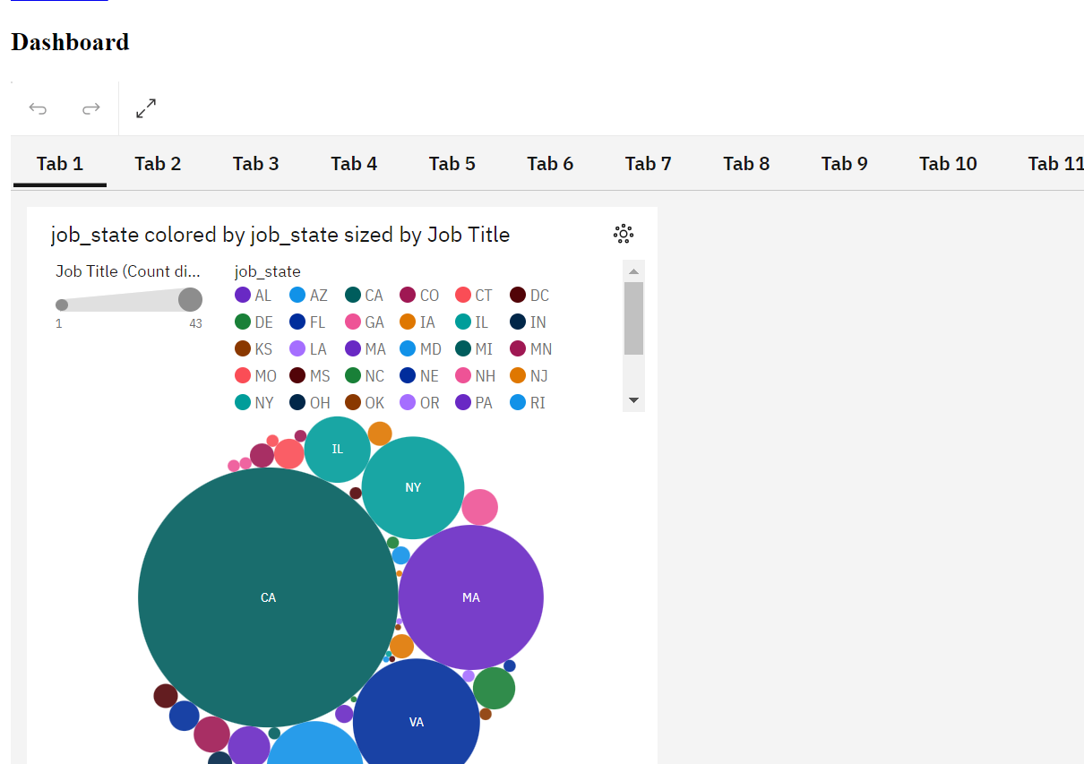



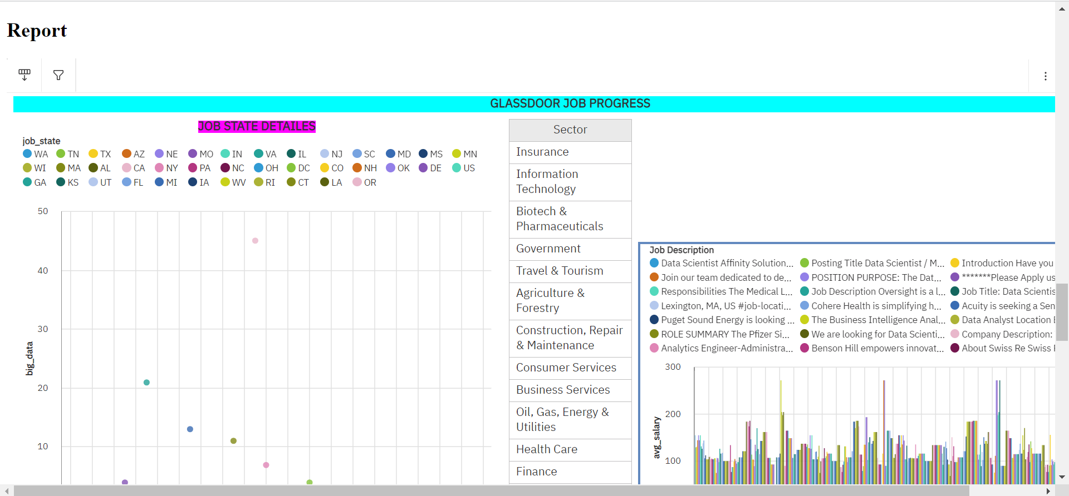

**CONCLUSION**

The future of work, as it pertains to platforms like Glassdoor, is expected to be shaped by several key trends and factors. Glassdoor, a platform that provides insights into company culture, salaries, reviews, and job listings, will likely continue to play a significant role in the evolving landscape of employment.

Glassdoor's future in the context of the evolving work landscape seems promising. Its role in fostering transparency, data-driven decision-making, remote work facilitation, and promoting positive workplace practices is likely to shape how job seekers and employers interact in the years to come. As the job market continues to transform, Glassdoor's evolution will be driven by its ability to adapt to emerging trends and effectively serve the needs of both job seekers and employers.